UNITED STATES

SECURITIES AND EXCHANGE COMMISSION

WASHINGTON, DC 20549

FORM 8-K

CURRENT REPORT PURSUANT

TO SECTION 13 OR 15(D) OF THE

SECURITIES EXCHANGE ACT OF 1934

Date of report (Date of earliest event reported): December 11, 2025

National Beverage Corp.

(Exact Name of Registrant as Specified in Its Charter)

Delaware

(State or Other Jurisdiction of Incorporation)

1-14170 | 59-2605822
(Commission File Number) | (IRS Employer Identification No.)
8050 SW Tenth Street, Suite 4000
Fort Lauderdale, Florida | 33324
(Address of Principal Executive Offices) | (Zip Code)

(954) 581-0922

(Registrant’s Telephone Number, Including Area Code)

(Former Name or Former Address, if Changed Since Last Report)

 |  |  | Securities registered pursuant to Section 12(b) of the Act:
 | Title of each Class |  | Trading Symbol |  |  | Name of each exchange on which registered
Common Stock, par value $.01 per share |  |  |  | FIZZ |  | The NASDAQ Global Select Market

Check the appropriate box below if the Form 8-K filing is intended to simultaneously satisfy the filing obligation of the registrant under any of the following provisions (see General Instruction A.2. below):

- Written communications pursuant to Rule 425 under the Securities Act (17 CFR 230.425)

- Soliciting material pursuant to Rule 14a-12 under the Exchange Act (17 CFR 240.14a-12)

- Pre-commencement communications pursuant to Rule 14d-2(b) under the Exchange Act (17 CFR 240.14d-2(b))

- Pre-commencement communications pursuant to Rule 13e-4(c) under the Exchange Act (17 CFR 240.13e-4(c))

Indicate by check mark whether the registrant is an emerging growth company as defined in Rule 405 of the Securities Act of 1933 (17 CFR §230.405) or Rule 12b-2 of the Securities Exchange Act of 1934 (17 CFR §240.12b-2).

Emerging growth company ☐

If an emerging growth company, indicate by check mark if the registrant has elected not to use the extended transition period for complying with any new or revised financial accounting standards provided pursuant to Section 13(a) of the Exchange Act. ☐

Item 2.02 Results of Operations and Financial Condition

On December 11, 2025, National Beverage Corp. (the “Company”) issued a press release announcing financial results for the periods ended November 1, 2025. The information in Item 2.02 of this report, including Exhibit 99.1, shall not be deemed “filed” for purposes of Section 18 of the Securities Exchange Act of 1934, as amended (the “Exchange Act”), or otherwise subject to the liabilities under that Section and shall not be deemed to be incorporated by reference into any filing of the Company under the Securities Act of 1933, as amended, or the Exchange Act.

Item 9.01 Financial Statements and Exhibits

(d)Exhibit 99.1 Press release dated December 11, 2025 announcing the Company’s financial results for the periods ended November 1, 2025.

Exhibit 104 Cover Page Interactive Data File (formatted as Inline XBRL)

SIGNATURES

Pursuant to the requirements of the Securities Exchange Act of 1934, the registrant has duly caused this report to be signed on its behalf by the undersigned thereunto duly authorized.

National Beverage Corp.

(Registrant)

By: |  | /s/ George R. Bracken
 | George R. Bracken
 | Executive Vice President – Finance
 | (Principal Financial Officer)

Date: December 12, 2025

EXHIBIT INDEX

99.1 Press release dated December 11, 2025 announcing the Company’s financial results for the periods ended November 1, 2025.

104 Cover Page Interactive Data File (formatted as Inline XBRL)

Exhibit 99.1
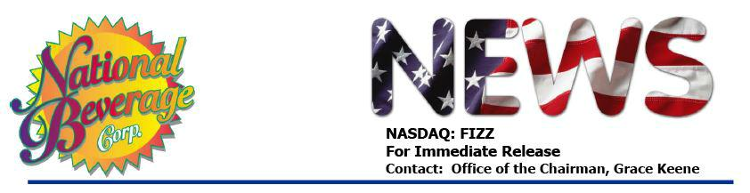

NATIONAL BEVERAGE CORP. SECOND QUARTER RESULTS UNDERSCORE RESILIENCE AND COMMITMENT TO MAXIMIZE SHAREHOLDER PERFORMANCE

FORT LAUDERDALE, FL, December 11, 2025 . . . National Beverage Corp. (NASDAQ: FIZZ) today announced results for its second quarter ended November 1, 2025.

For the three months:

- Net sales were $288 million;

- Operating income increased to $58 million; and

- Basic earnings per share increased to $.50.

For the trailing twelve months:

- Net sales increased to $1.2 billion;

- EBITDA* increased 63 basis points to $258 million;

- Earnings per share were $1.99; and

- Cash increased $156 million to $269 million.

“Second quarter results reflect the broader economic environment that many consumer-facing companies are navigating today. Ongoing inflation, elevated commodity costs, the continued impact of tariffs and the recent federal government shutdown have influenced purchasing behavior across the industry, with consumers becoming more cautious in their spending. While these external factors contributed to a modest decline in net sales, price/mix improvements resulted in increases in operating profit and net income, demonstrating the underlying strength and resilience of our business model,” stated a company spokesperson.

-more-
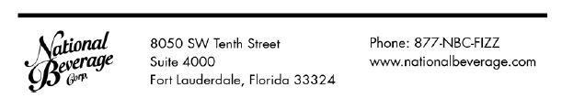

National Beverage Corp.

Page 2

“Importantly, our fundamentals remain strong and the elements of our business model remain resilient – unique brands positioned to leverage long-term health and wellness trends; long-standing relationships with major US retailers; exceptional consumer loyalty and an entrepreneurial management team noted for creativity and innovation. We have delivered excellent results for 40 years with a compounded annual return to shareholders of over 13%. During the second quarter, we repurchased 20,000 FIZZ shares prior to the start of our quarterly ‘blackout’ period. As stated in our October 30th announcement of the stock buyback program, ‘Our company remains fundamentally strong and continues to generate superior cash flows.”

“We are excited to introduce our newest LaCroix innovation, Pineapple Coconut, in early 2026. A radiant fusion of juicy pineapple sparkled with a velvety coconut finish, Pineapple Coconut delivers a sweet balance of flavor that’s . . .

Harmoniously Combined!”

“As we look forward to celebrating our 40th Christmas together as National Beverage Corp., we wish heartfelt blessings of peace and joy to all this special holiday season,” concluded the spokesperson.
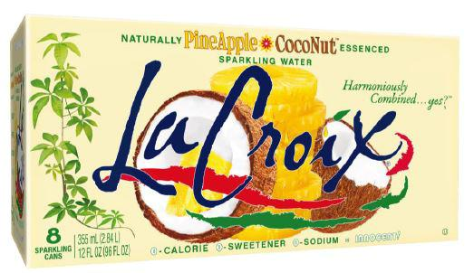

“Patriotism” – If Only We Could Bottle It!

-more-

National Beverage Corp.

Page 3

National Beverage Corp.

Consolidated Results for the Periods Ended

November 1, 2025 and October 26, 2024

 |  | (in thousands, except per share amounts)
 |  |  |  |  |  |  |  |  |  |  | Trailing Twelve
 |  |  |  | Three Fiscal Months Ended |  |  |  |  |  |  | Months Ended
 |  |  | November 1, 2025 |  |  |  | October 26, 2024 |  |  | November 1, 2025
 | Net Sales | $ |  | 288,331 |  | $ |  | 291,202 |  | $ | 1,199,525
 | Net Income | $ |  | 46,364 |  | $ |  | 45,637 |  | $ | 186,528
 | Earnings Per Common Share
 | Basic | $ |  | .50 |  | $ |  | .49 |  | $ | 1.99
 | Diluted |  | $ | .49 |  |  | $ | .49 |  | $ | 1.99
 | Average Common Shares Outstanding
 | Basic |  |  | 93,623 |  |  |  | 93,613 |  |  | 93,620
 | Diluted |  |  | 93,684 |  |  |  | 93,686 |  |  | 93,692

- Although the Company reports its financial results in accordance with accounting principles generally accepted in the United States ("GAAP"), management believes that the disclosure of EBITDA, a non-GAAP financial measure, may provide users of this financial information with additional insights into the operating performance of the business. EBITDA (in millions) for the trailing twelve months ended November 1, 2025 is calculated by adding Depreciation and Amortization of $21.3 and Provision for Income Taxes of $58.3 to Net Income and subtracting Net Interest Income of $8.2.

This press release includes forward-looking statements within the meaning of the Private Securities Litigation Reform Act of 1995. Forward-looking statements involve risks, uncertainties and other factors described in the Company's Securities and Exchange Commission filings which may cause actual results or achievements to differ from the results or achievements expressed or implied by such statements. The Company disclaims an obligation to update or announce revisions to any forward-looking statements.

